Student ID: Cse24-017

Student names: Gomolemo Alicia Meso

Student email: [cse24-017@thuto.bac.ac.bw](mailto:cse24-017@thuto.bac.ac.bw)

Cohort: CSE24

Assignment title: System Development

Date of submission: 19 November 2024

Programme of study: Computer Systems Engineering

Year of study: 1

**Intellectual property statement**

By checking the box below, I certify that this assignment is my own work and is free from plagiarism. I understand that the assignment can be tested for plagiarism by electronic or other means and can be transferred and stored in a database for data matching to help detect plagiarism. This assignment was not previously sent for assessment in any other unit or any other institution. **I have read and understood the Botswana Accountancy College plagiarism guidelines policy.**

Checkmark with solid fill Agree

Signature ......G.Meso........

Date ......19/11/24.........

My BnB

* PLANNING
* **Technical feasibility**
* Examine whether the available technology infrastructure can support a new reservation system.
* Figure out if new hardware or software is needed and if the team has technical ability to implement and support the system.
* Evaluate integration with existing systems and potential technical challenges.
* **Economic feasibility**
* Conduct a cost-benefit analysis to figure out if the investment in a new system will be profitable.
* Consider the costs of development, implementation and maintenance against the expected benefits such as increased efficiency and customer satisfaction.
* Analyze potential cost savings from reduced manual processes and improved resources management.

* **Schedule feasibility**
* Estimate the time needed to develop and implement the new reservation system.
* Examine whether the project timeline aligns with My BnB’s business goals and peak operational periods.
* Find any potential scheduling conflicts or resource constraints that could affect the project timeline.

* **Operational feasibility**
* Evaluate whether the new system will effectively solve the reservation challenges and improve operations.
* Consider the impact on staff and whether they can adapt to the new system with adequate training.
* Ensure the system aligns with My BnB’s operational processes and enhances customer experience.
* ANALYSIS

REQUEST FOR PROPOSAL

**Introduction**

MyBnB, a premier bed and breakfast chain, operates branches in Selepa, Gerald, Tatfiding, and Area W. To improve experience and operational efficiency, MyBnB is inviting proposals for the creation of a centralized reservation.

**Project overview**

Currently, each branch manages reservations independently using spreadsheets, leading to inefficiencies. We aim to implement a unified system to manage bookings, check-ins, check-outs, and customer transfers seamlessly across all locations.

**Project scope**

1. System development; develop and implement a centralized reservation system for all MyBnB branches.

* Provide system administrator capabilities to add new branches.

1. Features and capabilities; enable real-time room availability checks across branches.

* Support efficient reservation handling and modifications. Allow managers to manage room details and availability.
* Securely manage customer payment information and charge no-show fees.

1. User functionality; allow helpdesk staff to handle reservations both in-person and by phone.

* Reserve rooms at different branches when necessary.

1. Technical requirements; ensure compatibility with existing systems.

* Protect data in compliance with privacy regulations.

**Proposal requirements**

* Detailed description of the proposed system’s features.
* Project timeline.
* Detailed cost breakdown, including setup and ongoing fees.
* Company background and relevant project experience.
* Client references and examples of past work.

**Evaluation criteria**

* Technical capability and expertise.
* Cost-effectiveness.
* Project timeline and delivery plan.
* Vendor reputation and references.

We look forward to your proposal and the possibility of collaborating to enhance MyBnB’s services.

Functional requirements

* Reservation handling; the receptionist can make reservations requests personally or through a phone call.
* Room availability; reservations of rooms should be made by assistants at their branches.
* Inter-branch room availability; the receptionist must check the availability of rooms at other branches, if theirs is full.
* Payment details; customers must provide debit or credit card details for reservation.
* Billing; charge the customer’s account on the day of checkout.
* Cancellation policy; allow cancellations up to 24 hours before check-in, charge for late cancellations or no-shows one night’s lodging fee.

Non-functional requirements

* Security; secure customer details.
* Availability; reservation system should consistently be accessible for helpdesk purposes.
* Efficiency; quick processing system of reservation and availability.
* Reliability; reservations, cancellations and billing must be exact.
* DESIGN
* Use case diagram

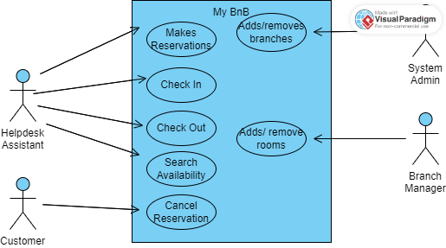

* Class Diagram

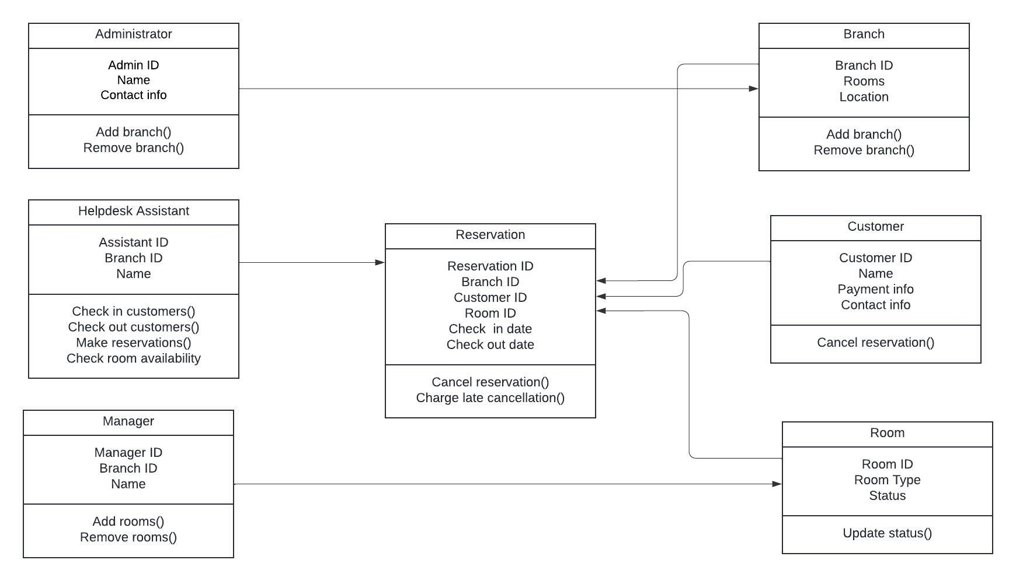

* Activity Diagram

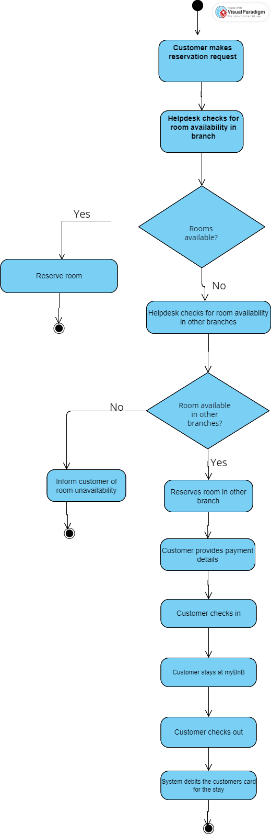

* Sequence diagram

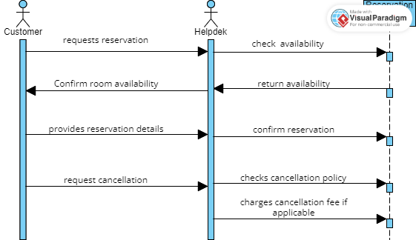

* Context Diagram

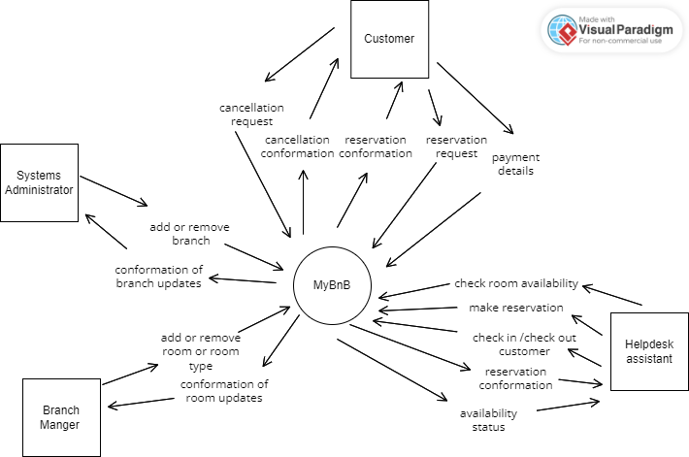

* Implementation
* Flowchart

* Pseudocode

Start

INPUT cancellation request

System checks cancellation policy

If cancellation is within cancellation window

then cancel reservation

Else

charge late cancellation fee

End If

Update reservation status

OUTPUT Cancellation successful

End

* Review
* Software table

|  |  |  |  |  |  |  |
| --- | --- | --- | --- | --- | --- | --- |
| ID | TASK | DEPENDENCE | EXPECTED TIME | EARLIEST FINISH TIME (EF) | LATEST FINISH TIME(EF) | CRITICAL ACTIVITY  (YES/NO) |
| 1 | Requirements | - | 10 | 10 | 10 | Yes |
| 2 | Analysis | 1 | 8 | 18 | 18 | Yes |
| 3 | Documentation | 1 | 15 | 25 | 44 | No |
| 4 | Logical Report | 2 | 6 | 24 | 24 | Yes |
| 5 | Report Design | 4 | 4 | 28 | 29 | No |
| 6 | Form Design | 4 | 5 | 29 | 29 | Yes |
| 7 | Implementation | 5,6 | 15 | 44 | 44 | Yes |
| 8 | Installation | 3,7 | 3 | 47 | 47 | Yes |

* Network Diagram

